QABF Sum Scores from all raters:

Special Education Teacher:
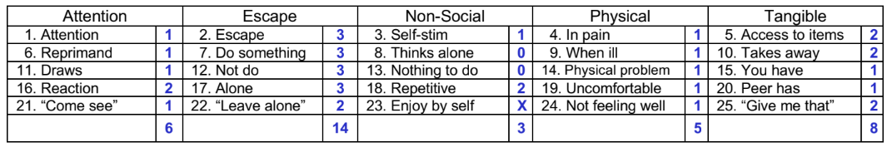
ParaPro (Thursday):
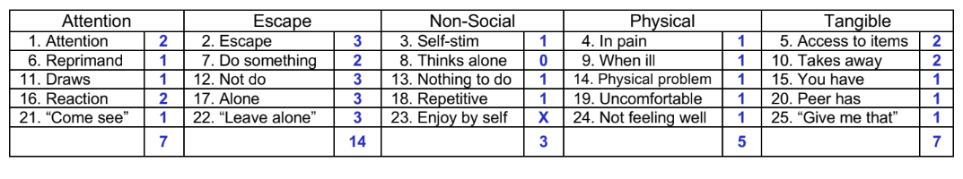
ParaPro (MWF):
