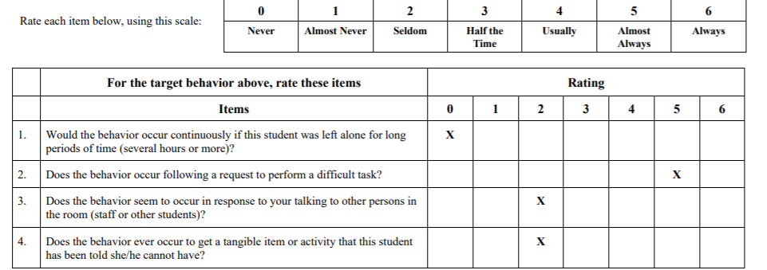
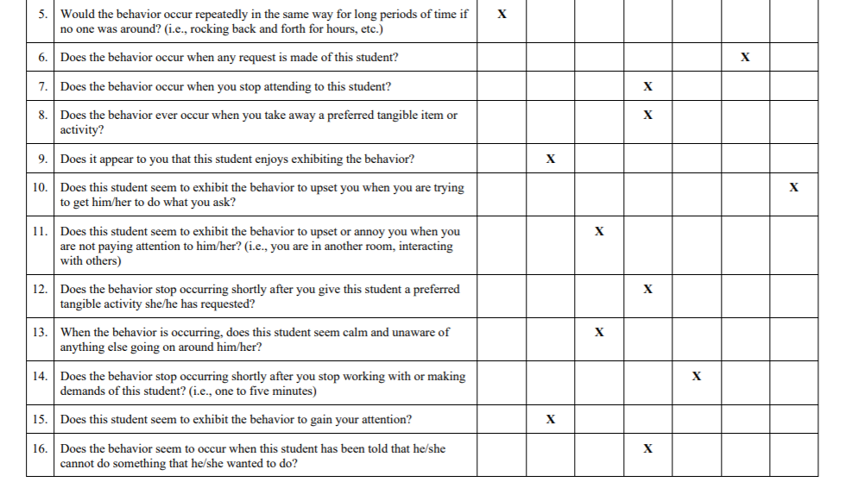
Scoring Instructions:
Record the rating for each item. Calculate the Sum for each function of behavior by adding up the ratings for the four items associated with that function of behavior. Higher sums indicate a greater likelihood that the target behavior serves that function.
Sensory |  | Escape |  | Attention |  | Tangibles
Item | Rating | Item | Rating | Item | Rating | Item | Rating
1 |  | 2 |  | 3 |  | 4
5 |  | 6 |  | 7 |  | 8
9 |  | 10 |  | 11 |  | 12
13 |  | 14 |  | 15 |  | 16
SUM = |  | SUM = |  | SUM = |  | SUM =

